GREENWOOD PUBLIC SCHOOL, DD NAGAR, GWALIOR
OUR MOTTO- DEVELOPMENT WITH DELIGHT
Session: (2020-2021)
Class-VII
Subject-Computer

Chapter – 1, Statements in small basic

- Answer the following question.
Q.1 Explain the If-Then-Else loop with an example.
Ans. The If-Then-Else loop is the extended form of If-Then. This is used to specify an alternate action when the condition is false. The syntax is:
If (Condition) Then
(Statements to be executed )
Else
(Statements to be executed )
Endif
Example: Write a program that takes 3 numbers. If the average of the numbers is greater than
or equal to 85, print “Grade = A”, otherwise print “You need to work hard!”.
Q.2 What is the function of DrawText method of Graphics Window? Write its syntax.
Ans. DrawText method of Graphics Window provide graphics related input output functionally.
This method writes a line of text at the location (x,y) using the font properties .
Syntax: DrawText (x, y, text
Q.3 Explain the font properties in Graphics Window.
Ans. The Graphics Window also allows to type text. we can specify its title, height, width and
background colour. The Font size and type can be set using Graphics Window font properties.
Such as:- GraphicWindow.FontName = “Name of the Font”.
Q.4 Explain the While…..End While Loop with an example.
Ans. When we don’t know the loop count beforehand, we can use the While loop instead of
For loop. When we use a While loop in a program, we state a condition that is true. But
the computer repeatedly executes until the condition become false.
Example: A = 5
While (A <= 50)
TextWindow.WriteLine (A)
A = A+10
EndWhile

Q.5 What will be the output of the following code?
For X = 1 to 5
TextWindow.WriteLine (X)
EndFor
Ans. 1
2
3
4
5

Class-VII
Subject-Computer
Chapter-2
Formulas and functions in MS Excel
INTRODUCTION: Microsoft Excel is a software program produced by Microsoft that allows users to organize, format and calculate data with formulas using a spreadsheet system. Microsoft Excel is a spreadsheet program included in the Microsoft Office suite of applications.
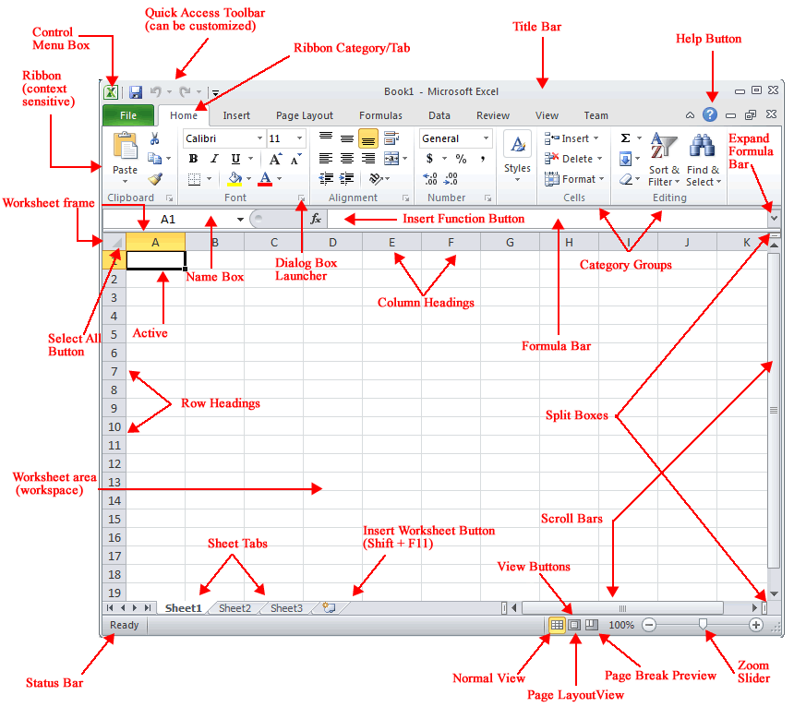
- Answer the following questions.
Q.1 What is a cell reference? Name all the cell references in MS Excel
Ans . A cell reference refer to a cell or a range of cell on a worksheet and can be
used formula. There are four types of cell references:- Relative, Absolute, Mixed
and Circular reference.

Q.2 Explain the AutoSum feature in MS Excel.
Ans. This Function automatically enters the suitable formulas or function into worksheet.
It sets the range of cells by looking for the numeric data above the selected cell.

Q.3 Explain the usage of If () Function with the help of example.
Ans. The If () Function returns one value. If a condition is true otherwise it returns false.
Example:-1. Select the cell J2. Type the Formula =If(G2>80, “A”, “B”), meaning if the If value in cell G2 I greater than 80, then show A else show B.

Q.4 Explain the difference between relative and absolute cell references.
Ans. Relative reference: A formula that contains relative reference changes when it is
copied from one cell to another. The reference of the row and column changes
on copying a formula.
Absolute reference:- A formula that contains an absolute reference does not
change when it is copied from one cell to another. To create an absolute reference ,
a dollar symbol ($) is placed in front of the column letter and the row number.

Q.5 What is string concatenation? How will you perform this in MS Excel.
Ans. In MS Excel, we can join text strings together.A text string is a sequence of
characters. Joining of two or more text strings is known a ‘string concatenation’.
Example: 1. To join the First and the last name of the cell A2 an B2 and display
result in C2, type the following formula in the cell C2: =A2&” ” &B2
2. Press the Enter key to see the result.

Q.6 What is mixed reference? Explain with an example.
Ans. A mixed reference I combination of either an absolute row and a relative column or a relative row and an absolute column. When we add ‘$’ before a column we can create an absolute column, and when we add ‘$’ before a row can create an absolute row. Example:- C3 is = $B3*C$2 These cell references are mixed references.

